The Analytical Side of Cardiac Implants

Willow G. Westbrook
Information Systems of Management, Suffolk University
Honours Undergraduate Research Project
Dennis Harkins
May 9th, 2023

The Analytical Side of Cardiac Implants
In this report, I conduct an overall analysis of the analytics of cardiac implants. That includes looking at the market, key market players, the business side of the market, the analytical side of the market, the progression of data analytics, as well as an outlook on the analytics involved in cardiac implants. I plan on expanding my knowledge and research over my time in graduate school, working towards honing the analytics of biotech companies to fully support all cardiac implant patients.

In the past 6 decades, implantable medical devices or systems have been advanced through developments in engineering and science, especially in microelectronics, biotechnology, and materials. Implantable medical devices were developed to sense a physiological response to actuate physiological organs. With the recent super miniaturization of electronic circuits and mechanical structures, researchers have focused on the development of implantable real-time vital monitoring systems, which are operated continuously in sub-second periods. Implantable real-time vital monitoring devices may shift medical systems from remedying incidents after they occur to self-managing incidents before they occur. The designing of an implantable medical device is initiated with information gathering from three main participants: the patient, the medical staff, and the engineer.

What are Cardiac Implants?
In 1960, the first electronic pacemaker was invented by John Hopps (Current Market Insights, 2022), the device resembled a small radio, it measured 30 centimetres in length and used vacuum tubes to generate pulses. Hopps then created transvenous catheter electrodes which could be passed through the external jugular vein and eliminate the need to open a patient’s chest for heart stimulation. The same catheter electrodes that were used in the first version of the pacemaker are still used in today’s modernized implantable versions (BC Medical Journal, 2017).
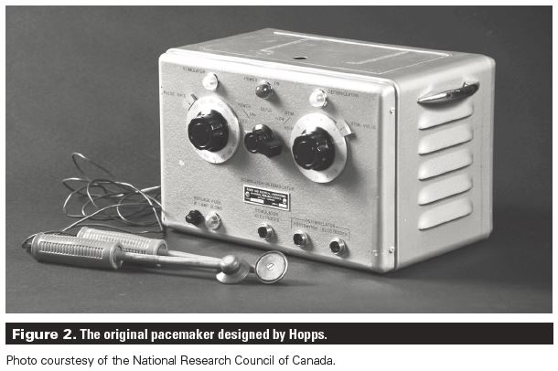
(John Hopps and the pacemaker: A history and detailed overview of devices, indications, and complications | British Columbia Medical Journal. (2017). Bcmj.org. https://bcmj.org/articles/john-hopps-and-pacemaker-history-and-detailed-overview-devices-indications-and)

Cardiac implants are implantable medical devices that monitor the arrhythmias in patients who suffer from heart disorders such as heart failure, ventricular tachycardia, ventricular fibrillation, and various others. These have become the cornerstone of management for patients with heart disorders over the decades, rhythm management devices may also improve the life expectancy and quality of life for patients.
The objective of a cardiovascular implant is to assist in relieving a slow and/or irregular rhythm for a patient. Impressive progress in the field of cardiac implants has led to technical improvements in existing devices and leads, and new versions are constantly emerging. Increasing development of new cardiac implants and increasing engagement of business development strategies, such as collaboration between key market players, are expected to also aid market growth (Coherent Market Insights, 2022).
The market is expected to witness significant growth over the next decade, bowing to the increasing focus of market players on technological innovations in the field of cardiac implantable devices.

What the market currently looks like
The global cardiac implants market was estimated to be valued at US$ 35,795.6 million in 2022, the market is expected to show a compound annual growth period of 8.1% from 2022-2030 (Coherent Market Insights, 2022). Increasing risk of cardiovascular disease due to changes in lifestyle and dietary habits is expected to drive market growth, as well as technological innovations in the field of cardiac implants are expected to display remarkable growth over the next decade.
The cardiac market is segmented by product (Implantable Cardioverter-Defibrillators (ICDs), pacemakers, coronary stents, implantable heart rhythm monitors, implantable hemodynamic monitors, etc.), its application (arrhythmias, acute myocardial infarction, myocardial ischemia, and other applications…), its end-user (hospitals, cardiology center’s, etc.), and geography (Europe, America, Asia-Pacific, Middle East, and Africa) (Modor Intelligence, 2023). The implantable cardioverter defibrillators (ICDs) segment is expected to grow faster and dominate the cardiac implant market over the next decade in the device-type segment. This is also a major market trend in the forecast of the market.
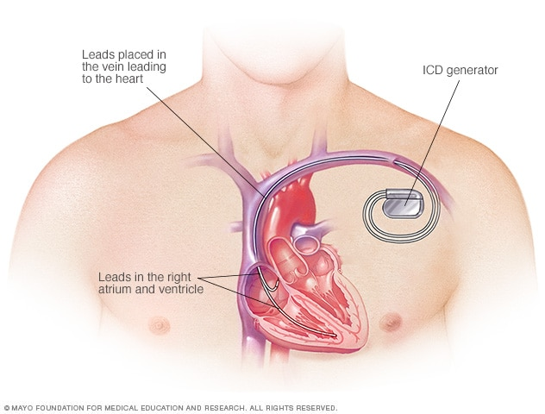
(Mayo Clinic. (2017). Implantable cardioverter-defibrillators (ICDs) - Mayo Clinic. Mayoclinic.org. https://www.mayoclinic.org/tests-procedures/implantable-cardioverter-defibrillators/about/pac-20384692)

An ICD is a small battery-powered device that is implanted in the chest of a patient to detect and stop irregular heartbeats (arrhythmias). An ICD continuously monitors the heartbeat and delivers electric shocks to restore a regular heart rhythm when it is needed. This segment is forecasted to witness significant growth owing to factors such as the increasing cases of cardiovascular disease and the increasing adoption of technologically advanced products (Modor Intelligence, 2023).
Growing cases of heart failure and the increasing frequency of cardiovascular diseases represent one of the key factors that are directly influencing the demand for cardiac implants worldwide. Inactive lifestyles, unhealthy dietary patterns, elevated stress levels, diabetes, and obesity are also big contributors to the demanding market. There is also an increase in preferences for minimally invasive surgeries due to their associated benefits. Integration of AI, predictive analytics, and advanced algorithms has aided in the early detection of heart disease.
The global market is segmented based on the regions: Europe, America, Asia-Pacific, Middle East, and Africa. North America is expected to hold the largest market share for its high adoption rates of cardiac implant devices, and an increase in prevalent cardiac diseases. In Europe, the global market is growing for factors like increasing the government’s healthcare sector funds and increasing the number of initiatives for cardiac patients by insurance companies (Gotadki, 2019).
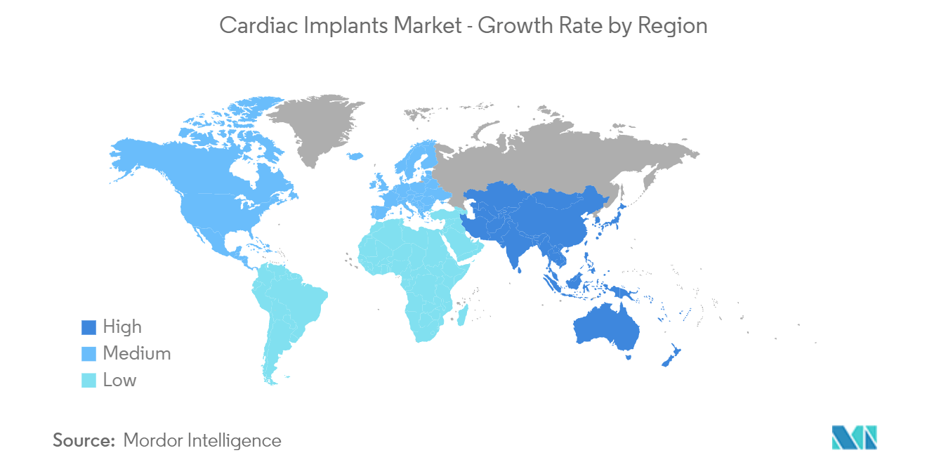
(Cardiac Implants Market Size & Share Analysis - Industry Research Report - Growth Trends. (n.d.). Www.mordorintelligence.com. Retrieved May 3, 2023, from https://www.mordorintelligence.com/industry-reports/cardiac-implants)

North America holds the major market share in the cardiac implants market, the CDC recorded a spike in deaths related to heart disease from 2019-2020 within the United States. It is also estimated that 12.1 million people in the United States will have atrial fibrillation by 2030, aided by the increase in the prevalence of cardiovascular diseases will drive market growth for cardiac implants. The North American region has also experienced new product approvals and launches by prominent market players operating within the cardiac implant market that will further boost the market’s regional growth. In April 2022, Abbott received approval from the United States Food and Drug Administration (FDA) for the Aveir single-chamber (VR) leadless pacemaker for the treatment of cardiac patients with slow heart rhythms in the US (Modor Intelligence, 2023).
Despite new developments, cardiac implants may have a downside associated with complications that come with using medical devices. Restraints of the global cardiac implant market are the increasing product recalls and cardiac implant-related infections. Short-circuiting is another problem that medical device companies face, this decreases battery life which results in devices producing a warning that the battery is low, earlier than expected. Many complications are related to the transvenous lead and the subcutaneous pocket. The transvenous leads can cause dislocation, mechanical damage, tricuspid regurgitation, venous occlusion, superior vena cava syndrome, cardiac perforation, and infective endocarditis (Kotalcyzk, 2020). Subcutaneous pockets can also cause a hematoma, decubitus, and inflammation.

Progression of Analytics Involved
The outbreak of Covid-19 positively influenced the growth of the cardiac implant market. With the rising cases of covid-19 across the globe, this put a heavy strain on the global healthcare sector. A rise in cardiac patients and cardiovascular diseases, who were highly prone to be infected by the coronavirus, visualized the strong growth of cardiac implants during the pandemic. It is also clear that the pandemic was accelerated by the adoption of digital and remote research technologies.
Leadless cardiac PMs and extravascular cardioverter defibrillators have been designed to minimize the complications associated with cardiac implants. The conventional monitoring of cardiac implants and limited contact with patients is insufficient and outdated. Digital healthcare models and remote control of devices are the future of modern medicine and cardiology. They involve patients taking an active role in their own clinical care, and a personalized approach, including shared decision-making, is also crucial.
Tele-transmission systems transfer data recorded from the patient’s device to a database, where the data is available to the health care team. New systems also transmit the data via the patient’s smartphone or tablet, or they are provided with a device that is already connected to their cardiac implant, solely for recording symptoms and checking connection issues. Telemonitoring allows the assessment of the relevant technical parameters of the device such as battery status, electrode function, and system compatibility on an ongoing basis, it also provides key clinical information (Kotalczyk, 2020).
An absorbable, antibiotic-eluting envelope has also been created to use with cardiac implants as a prophylactic strategy to prevent cardiac device-related infective endocarditis. Patients with cardiac implants usually have routine in-person appointments to verify whether the device is functioning properly and for assessment of clinical findings every 6-12 months.
In April 2022, Abbott received approval from the United States Food and Drug Administration (FDA) for the Aveir single-chamber (VR) leadless pacemaker for the treatment of cardiac patients with slow heart rhythms in the US (Modor Intelligence, 2023). Using the power of leadless technology, the Aveir VR Leadless Pacemaker is implanted in the heart through a minimally invasive cardiac catheter procedure.
This leadless pacemaker is designed for chronic retrieval using a dedicated retrieval catheter. The Aveir VR Leadless Pacemaker active fixation helix uses a screw-in mechanism to enable both implantation and chronic retrieval of the pacemaker. The device has an overall chronic retrieval success rate of 88%, although there is only limited data available. As well as a projected life of the battery at 10.3 years, which is twice the projected longevity of current VR leadless pacemakers (Abbott, 2023).
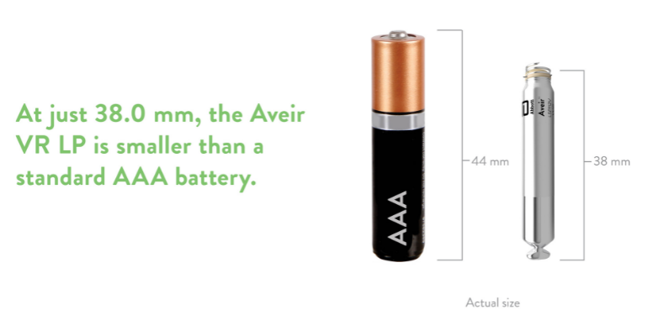
(And Now There Are 2 Leadless Pacemakers. (2022, April 4). Mddionline.com. https://www.mddionline.com/cardiovascular/and-now-there-are-2-leadless-pacemakers)
Unlike traditional pacemakers, leadless pacemakers do not require an incision in the chest to implant the device or cardiac leads to deliver energy to the heart. Instead, they are implanted directly into the heart's right ventricle, via a minimally invasive procedure. Abbott's Aveir system is unique from the rest because it is the world's only leadless pacemaker that is specifically designed to be retrieved when the device needs to be replaced or if a patient's plan of care needs to be changed (Abbott, 2023).

Market Players and Their Market Position
Key players who are currently operating in the global cardiac implant market are Boston Scientific Corporation, Stryker Corporation, Biotronik, Medtronic, and Asahi Kasei Corporation. The key strategies followed by market players are product development, innovation, acquisition, and expansion. One of the leading companies, Medtronic, launched an advanced technology Implantable Cardioverter-Defibrillator (ICD) device that allows patients to gather information by holding an antenna over the implanted cardiac device (Gotadki, 2019).

Business Position of Market Players
Businesses that can effectively navigate the risks and opportunities presented by new research technologies are likely to hold a competitive advantage in their market. The massive unexplored cardiac bio-implant devices market in emerging economies is creating ample opportunities for the growth of the global cardiac implant market at a considerable rate in the coming decade. Advanced research and development activities and new product developments by market players are supporting the demand for cost-effective and efficient cardiac implant devices, fuelling the growth of the market (PS Intelligence, 2022).
To gain a competitive edge in the industry, top suppliers are focusing on providing their clients with high-quality, economical, and new technologies employing existing materials. Whereas leading producers compete in terms of price, quality, design, and aftermarket support. the competition within the market is increasing and getting better because of technological know-how and investments made through partnerships and agreements (Shah, 2022).

Analytical Position of Market Players
Recent technological advances have opened the opportunity of developing innovative and new smart stent devices that incorporate electrical properties that can improve diagnosis and even treatment of previously intractable conditions. Developments in biotechnology, microelectronics, and material science have now started to make it possible to overcome many restraints that come with cardiac implants. in recent years, there have been significant advances in low-power miniaturization of devices with highly integrated circuits. The advances in microelectronics energy efficiency, ensuring long life, and improvements in biocompatibility and communication protocols have allowed systems with real-time vital monitoring to be implanted and to communicate wirelessly to report on chronic and acute medical conditions.
Outlook on the Analytical Side over the Next Decade
Miniaturization has immensely reduced the size of cardiac implants while simultaneously facilitating advances in their medical therapeutic capabilities. Additional advances in leadless pacing are likely to revolutionize the field in the near future. Smaller more maneuverable leads have made cardiac resynchronization therapy a practical and mainstream technique. Implantable monitoring for heart failure recipients promises to reduce readmission rates and facilitate ongoing assessments of various pharmacological therapeutic interventions. Implantable loop recorders extend the availability to find the cause of unexplained syncope, define the etiology of infrequent palpitations, and unveil atrial fibrillation. Smaller faster devices with greater capabilities hold great promise to help patients live longer and better electrically.
With a high placement on research and development when it comes to key market players, we can expect to keep witnessing analytical advancements within cardiac implants, with the goal of fulfilling all cardiac patients’ needs.

References
Kotalczyk, A., Kalarus, Z., Wright, D. J., Boriani, G., & Lip, G. Y. H. (2020). Cardiac Electronic Devices: Future Directions and Challenges. Medical Devices: Evidence and Research, Volume 13, 325–338. https://doi.org/10.2147/mder.s245625
John Hopps and the pacemaker: A history and detailed overview of devices, indications, and complications | British Columbia Medical Journal. (2017). Bcmj.org. https://bcmj.org/articles/john-hopps-and-pacemaker-history-and-detailed-overview-devices-indications-and
Services, D. of H. & H. (n.d.). Implantable cardiac devices. Www.betterhealth.vic.gov.au. Retrieved May 3, 2023, from https://www.betterhealth.vic.gov.au/health/conditionsandtreatments/artificial-cardiac-pacemakers#about-implantable-heart-devices
Swerdlow, C. D., Brown, M. L., & Bordachar, P. (2017). Sensing and Detection With Cardiac Implantable Electronic Devices. Clinical Cardiac Pacing, Defibrillation and Resynchronization Therapy, 114–167. https://doi.org/10.1016/b978-0-323-37804-8.00004-3
Poh, P. G., Liew, C., Yeo, C., Chong, L. R., Tan, A., & Poh, A. (2017). Cardiovascular implantable electronic devices: a review of the dangers and difficulties in MR scanning and attempts to improve safety. Insights into Imaging, 8(4), 405–418. https://doi.org/10.1007/s13244-017-0556-3
Abi-Samra, F. M. (2011). Cardiac Implantable Electrical Devices: Bioethics and Management Issues Near the End of Life. The Ochsner Journal, 11(4), 342–347. https://www.ncbi.nlm.nih.gov/pmc/articles/PMC3241068/
https ://www.coherentmarketinsights.com, C. M. I. (n.d.). Cardiac Implants Market Size, Trends and Forecast to 2030. Www.coherentmarketinsights.com. Retrieved May 3, 2023, from https://www.coherentmarketinsights.com/market-insight/cardiac-implants-market-1176
Cardiac Implants Market Size & Share Analysis - Industry Research Report - Growth Trends. (n.d.). Www.mordorintelligence.com. Retrieved May 3, 2023, from https://www.mordorintelligence.com/industry-reports/cardiac-implants
‌ Cardiac Implants Market Research | 2023-2030. (n.d.). MarketWatch. Retrieved May 9, 2023, from https://www.marketwatch.com/press-release/cardiac-implants-market-research-2023-2030-2023-05-08#:~:text=The%20Global%20Cardiac%20Implants%20market
https://www.stratviewresearch.com, & https://www.stratviewresearch.com/2402/Heart-Implants-Market.html. (2023, May 9). Heart Implants Market | Market Size, Share & Forecast Analysis. Stratviewresearch.com. https://www.stratviewresearch.com/2402/Heart-Implants-Market.html
How the Aveir VR Leadless Pacemaker Works | Abbott. (n.d.). Www.cardiovascular.abbott. Retrieved May 9, 2023, from https://www.cardiovascular.abbott/us/en/hcp/products/cardiac-rhythm-management/pacemakers/aveir-vr-leadless-pacemaker/how-it-works.html
Leadless Pacemaker Keeps the Beat? Bravo, Aveir! Bravo! (n.d.). Abbott. Retrieved May 9, 2023, from https://www.abbott.com/corpnewsroom/healthy-heart/leadless-pacemaker-keeps-the-beat-bravo-aveir-bravo.html
‌ Cardiac Bio-Implant Devices Market Insight and Demand In-Depth Analysis, 2030. (n.d.). P&S Intelligence. Retrieved May 9, 2023, from https://www.psmarketresearch.com/market-analysis/cardiac-bio-implant-devices-market
‌
News, E. I. N., & Shah, M. (2022, September 7). Cardiac Implants Market to Surpass US$ 66,953.4 Mn by 2030. EIN News. https://www.einnews.com/pr_news/589739972/cardiac-implants-market-to-surpass-us-66-953-4-mn-by-2030
‌

